TABLE OF CONTENTS

1. INTRODUCTION….……………………………………………………………………….2

2. INSTALLATION….………………………………………………………………………..3

3. REGISTRATION….……………………………………………………………………….4

3.1. USER CONSTRAINS……………………………………………………………6

4. QUIZ………………………………………………………………………………………..7

4.1. LOGGING INTO APPLICATION……………………………………………….10

4.2. TAKING THE QUIZ ……………………………………………………………11

5. FEATURES…………………………………………………………………………………12

5.1. INTERACTING WITH USER……………………………………………………13

5.2. SCRIBBLE PAD………………………………………………………………….14

6. RESULTS………………………………………………………………………..…………15

6.1. REPORTING SCORE……………………………………………………………16

6.2. SHOWING RESULTS…………………………………………………………...17

**1.Introduction**

Interactive Quiz application is a dynamic application which facilitates users to take quizzes online through web portal or as well through a mobile application. Details of the tests taken with their results are accessible to the user at any time. Users can take tests, retake tests and view written tests results in this application.

The application is interactive which can be installed on any mobile devices like ANDROID or IOS platforms. The application can speak out loud with the user and provides a flexibility to scribble while test going on. The results for each session will be shown with a time stamp and the right answers are also shown to enable to user to validate his answers and perform well for the next sessions.

**2.INSTALLATION**

Like any other mobile applications, it is also will get installed through an apk(android) file. App permissions will be given at the time of installing itself. App will be installed with an app name Interactive Quiz application.



**3.REGISTRATION**

Below steps are necessary for the creation of a user on any of the web & mobile platforms.



Registration page on mobile:

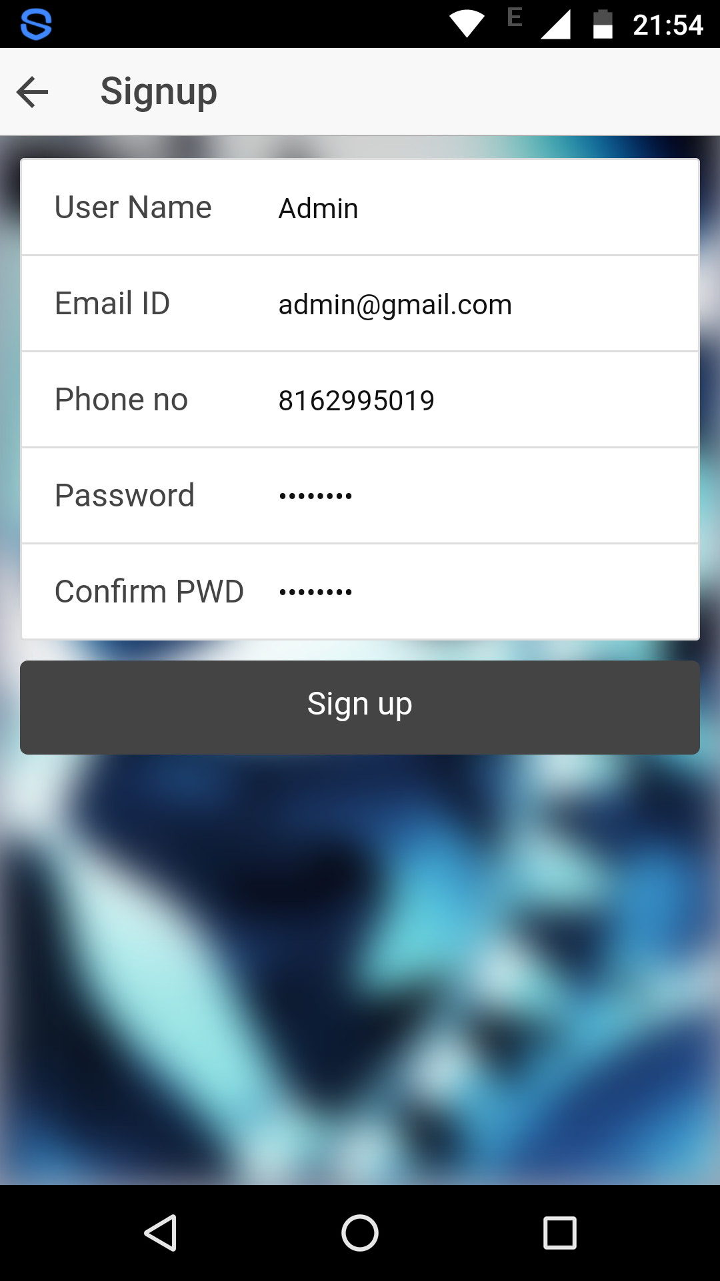

Registration successful on web:

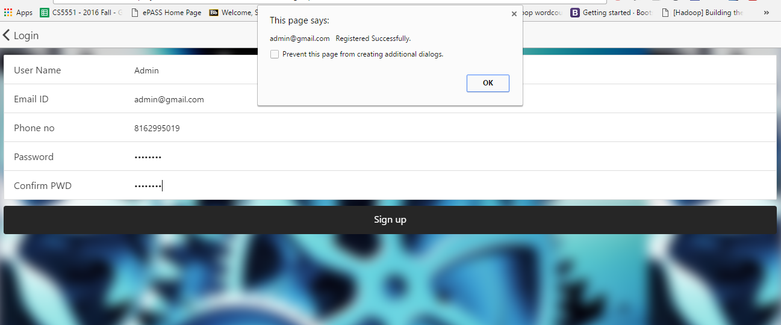

Registration successful on mobile:

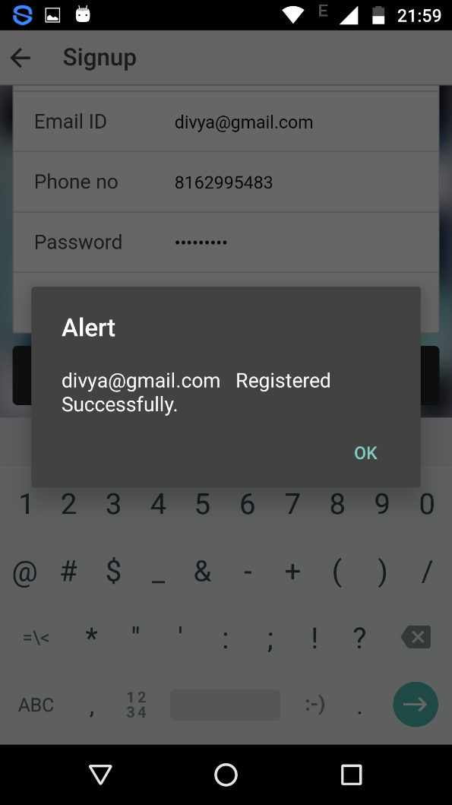

**3.1. USER CONSTRAINS**

While registering few constraints like password matching and password policy length should be greater than 8 digits.

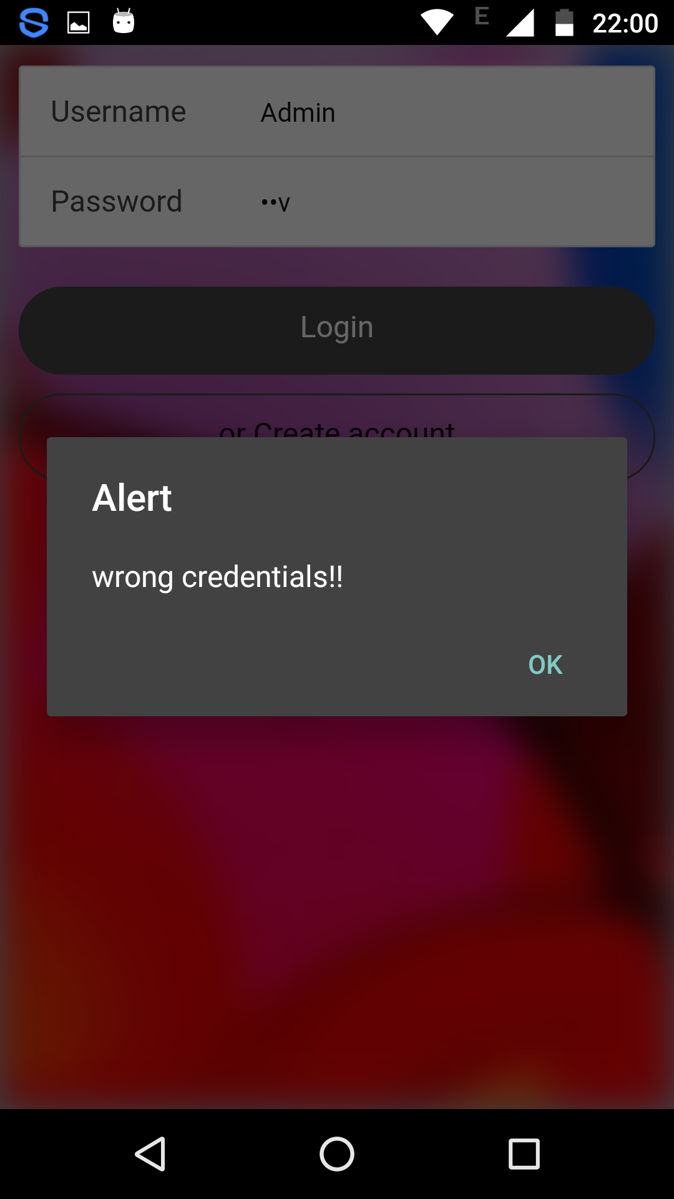

**4. QUIZ**

**4.1. LOGGING INTO APPLICATION**

Login page on web:



Login page on mobile:

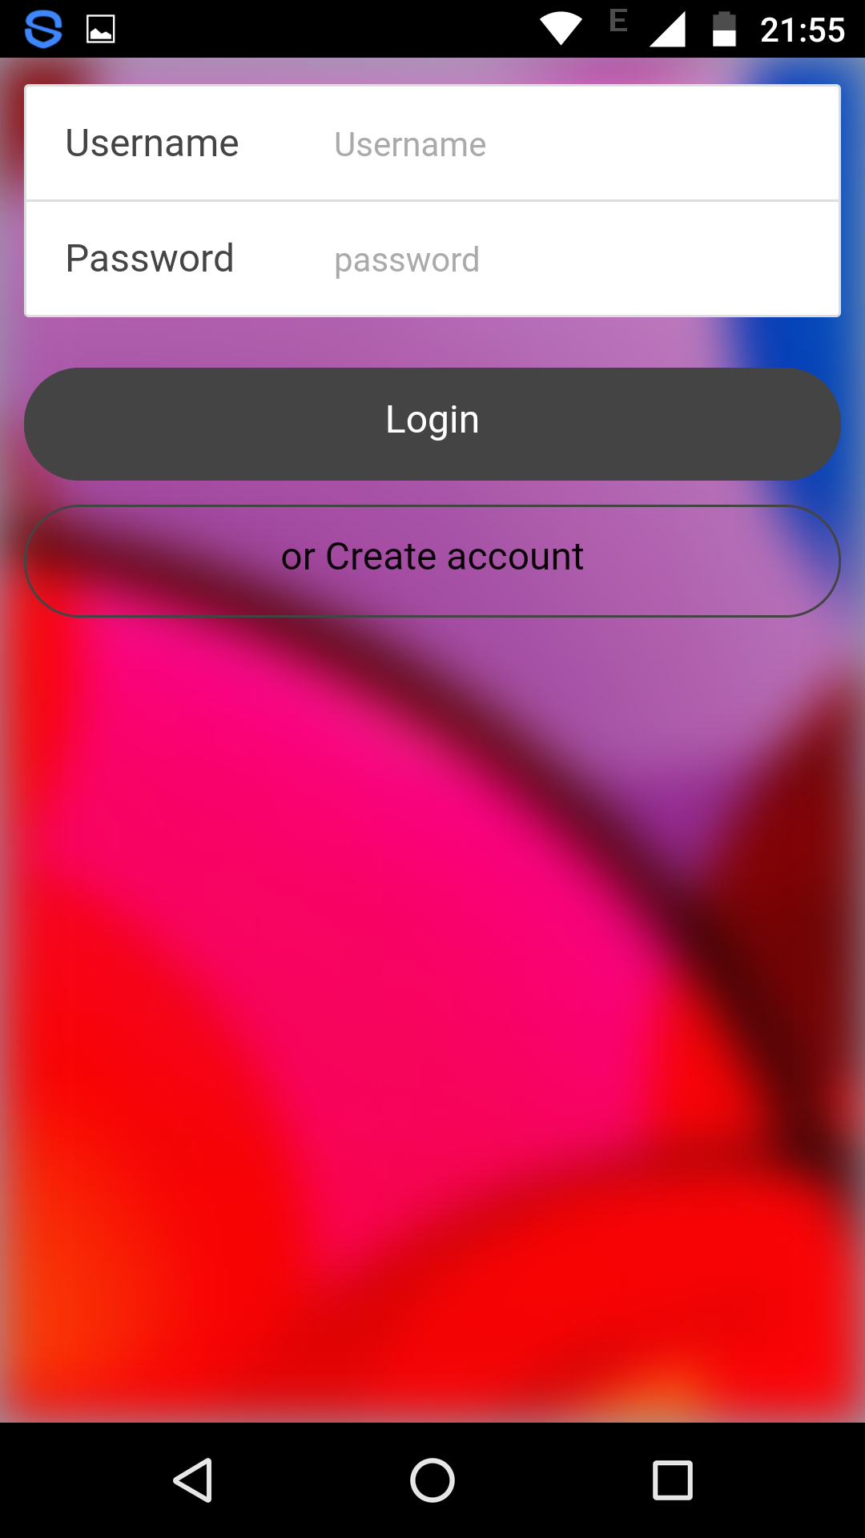

Home page on web:

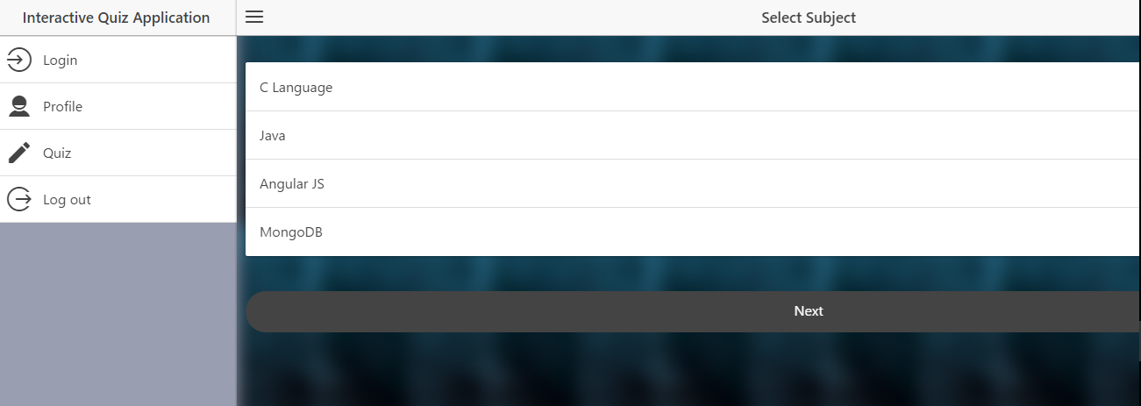

Home page on mobile:

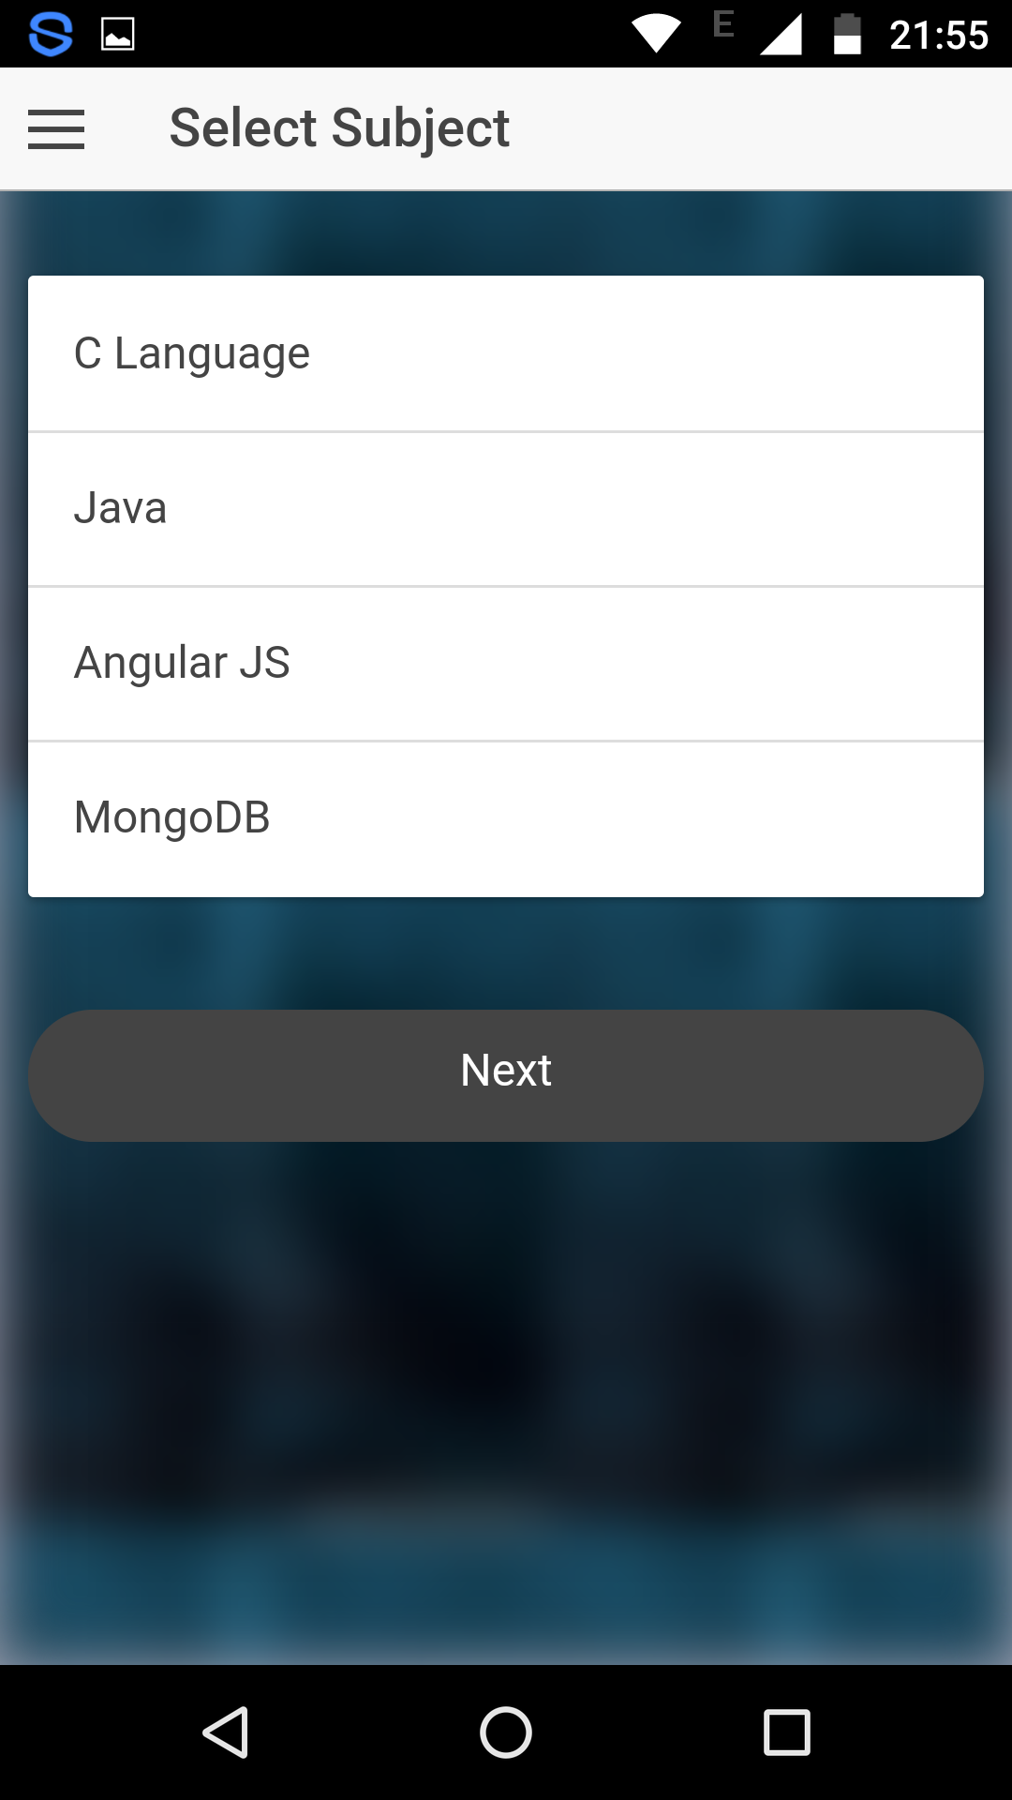

**4.2. TAKING THE QUIZ**

Quiz page on web:

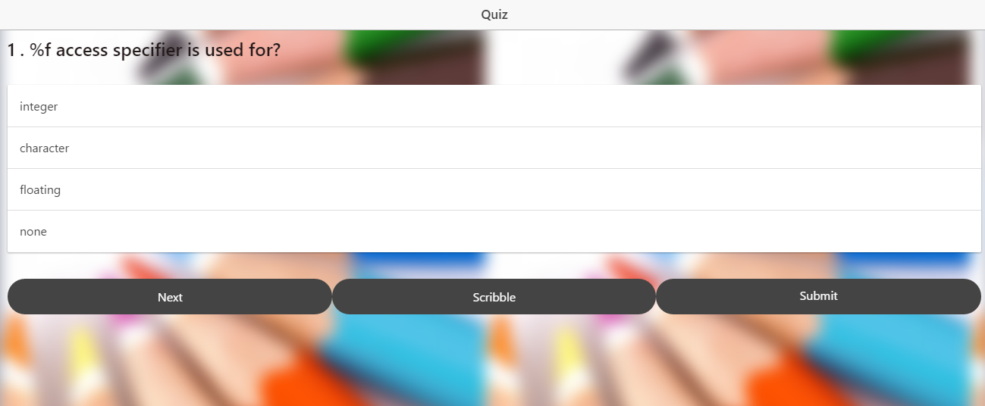

Quiz page on mobile:

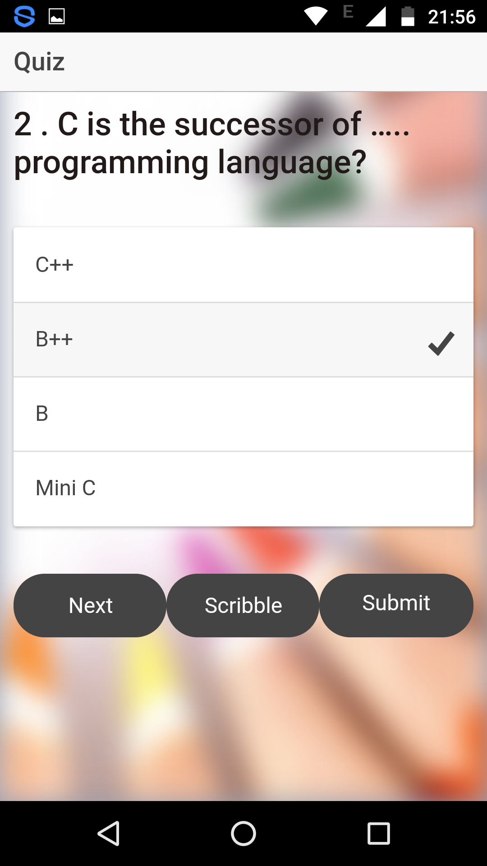

**5. FEATURES**

**5.1. INTERACTING WITH USER**

Application is interactive. It will speak out loud the quiz questions and options upon tapping those questions and options.

**5.2. SCRIBBLE PAD**

Scribbling pad on web:

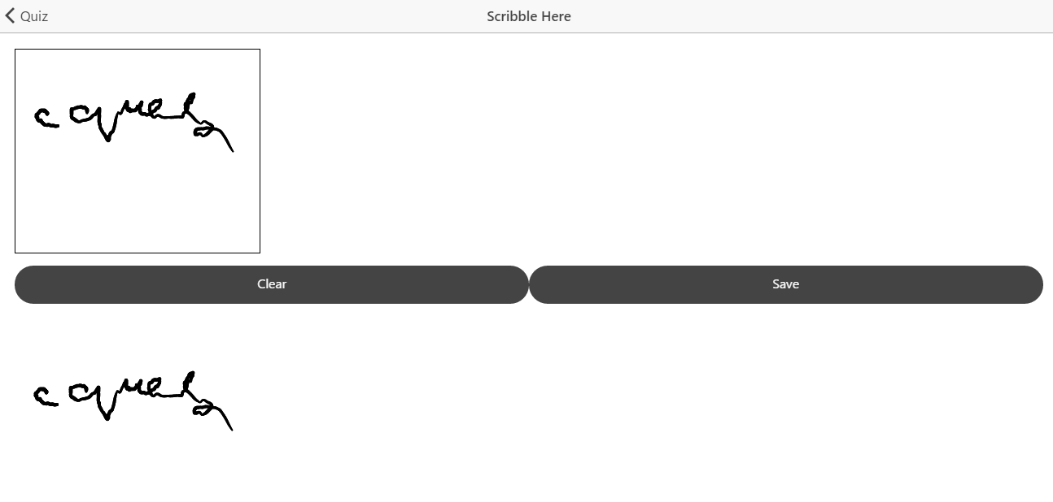

Scribbling pad on mobile:

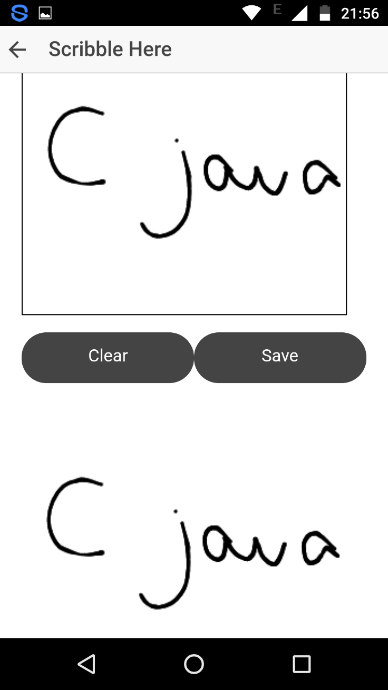

**6. RESULTS**

**6.1. REPORTING SCORE**

Score will be reported instantaneously upon submitting the quiz. There is a prevalence to submit the quiz even in the middle , one will be evaluated only for those questions he/she has taken till the time of submission.

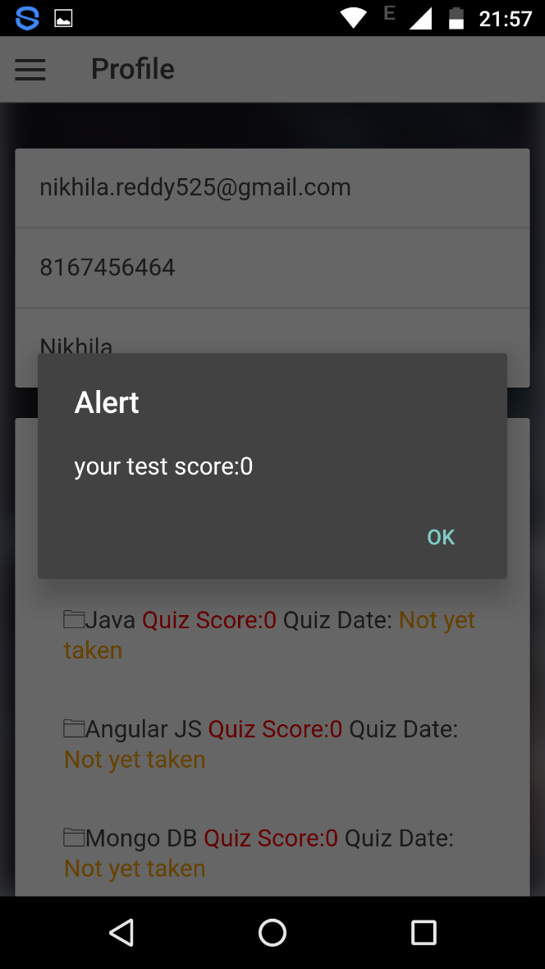

**6.2. SHOWING RESULTS**

Profile page on web:

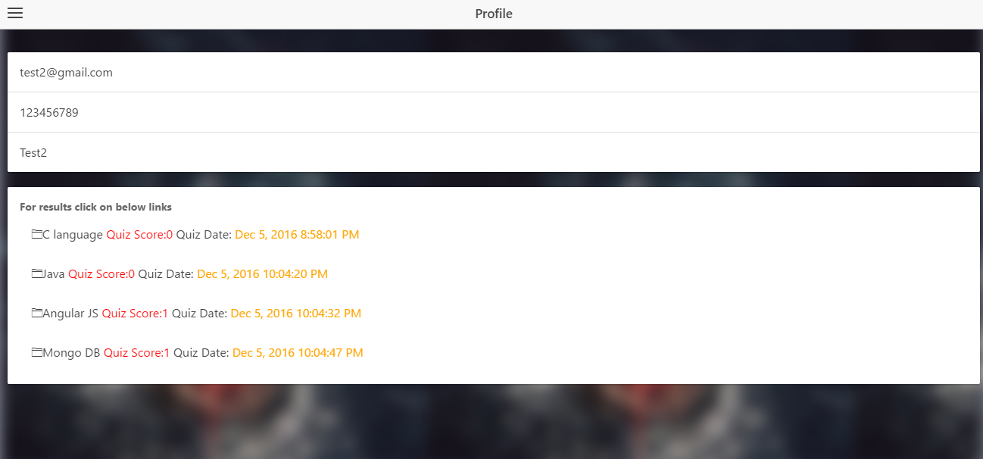

Profile page on mobile:

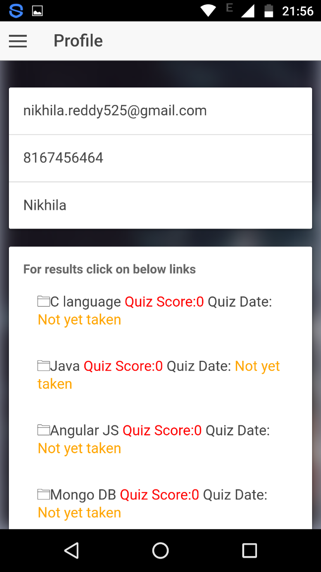

Attepted questions and answers after the test is done on web:



Attempted questions and answers after the test is done on mobile:

